Street Law as a unique learning method: What do students themselves actually find to be its benefits? Answers from the Czech Republic
Hana Draslarová
Abstract:
Street Law is believed to be a unique learning method. But do Street Law university students actually acknowledge the benefits Street Law is supposed to bring them? Has a Street Law course influenced them for their future? And how? This paper focuses on the benefits of Street Law for university students based on the empirical research conducted among the graduates of the Street Law course at Charles University in Prague, Faculty of Law, during which law students teach law in secondary schools. To find out whether Street Law actually provided the graduates with benefits, which are often stated in the literature as well as during the courses, all of the Street Law graduates were approached with a questionnaire. The paper focuses on the results – it shows which particular skills Street Law graduates feel have improved, whether they feel it has helped them to improve their legal knowledge or influenced their values. It also focuses on the opportunities Street Law skills can provide in legal practice and whether Street Law somehow influenced the teaching careers of its graduates. Although the research is not on a large scale, it creates an interesting picture about the impact of this untraditional type of education from the perspective of one of the target groups. In general Street Law graduates in the Czech Republic confirmed that they find Street Law to be a strong educational tool for faculties of law to produce better lawyers.
- Introduction
Can Street Law produce better future lawyers? We (people involved in conducting Street Law) believe Street Law to be a very beneficial experience for the students. But do the students actually feel the same? Has Street Law influenced them for their future? And if it has, how?
While many texts focus on the positive impact of Street Law on society, this paper will exclusively consider the impact of the Street Law course on the university students and the benefits Street Law brings them based on empirical research. Since its beginning in 2009 almost 300 students have undertaken the basic Street Law course at Charles University in Prague, Faculty of Law. The aim of the research was to find out whether the Street Law graduates in Prague consider that they have achieved the positive outcomes of Street Law which are often stated in the literature and will be further analysed below. Therefore the Street Law graduates were approached with an anonymous questionnaire, which should confirm whether and how much do students feel Street Law had influenced them and this paper will focus on the results of the research. The impact of Street Law as a form of clinical legal education will be approached from the perspective of the target group. Although the research is not a large scale research it intends to create an interesting picture about the impact of this untraditional type of educational activity. Moreover, this article should serve as an example of impact research of Street Law in civil law country, as many texts concerned with the impact of Street Law are from common law countries.
The overall question was whether Street Law can actually produce better lawyers, or whether it serves just as an enjoyable elective module which is suitable for those who would like to teach in the future. The aim of the research was to find out, how the students feel in relation to three main questions:
- What benefits (skills, knowledge and values) have they gained by passing the Street Law module?
- Have they actually used skills and knowledge from Street Law in legal practice?
- How did Street Law influence their future teaching careers?
In the following paragraphs first the Street Law course is described shortly, then the research details are provided and finally the data outcomes are presented.
- Street Law course in Prague
Street Law, during which mainly law students teach law to non-lawyers, is a well-known and established unique learning method. However, as Street Law programmes take different forms all over the world it is important to at least briefly introduce the Street Law course in Prague to set up the general background for the research results.
In Prague the basic Street Law course (which will further only be called the Street Law course) is a one term elective module. At first, students undertake intense training focused on how to teach law to non-lawyers, presentation skills, lesson planning etc. Following that they deliver at least ten law lessons to secondary school students, usually in pairs, and reflect upon their experience with the Street Law course teacher and other peers. They are rewarded with 7 credits – but the question is, what else do they gain? The course was first offered in 2009 and the module has been open twice in each academic year since then. From the academic year 2009/2010 until the academic year 2017/2018, 288 students have passed the course.
- Research objectives and research data
The aim of the research was to find out how the graduates assess the impact of Street Law on them. How do they reflect on their Street Law experience regarding the outcomes of the course? Which skills do they feel to have taken from Street Law? And how often have they used them? Did Street Law course influence their future activities or even careers? What do the students identify as important aspects of the Street Law? And last but not least, how did it impact on their involvement in teaching activities?
All of the 288 graduates were approached with an anonymous questionnaire, which aimed to find out whether and how much do students feel Street Law had influenced them. Overall there was 103 replies; that means the research results are based on answers from 36% of all Prague Street Law graduates.
Questions were often choice formulated, however it was interesting to find out that when students were given an optional chance to an open answer, they used them very often and these answers are to be found very interesting and valuable.
What does a typical respondent and his or her Street Law experience look like based on the questionnaire? There was almost the same number of female or male respondents (51:49%). She or he was teaching in schools in Prague (91%) and in pairs (68%, with the rest either teaching on their own or in groups of 3). Replies across all the years were gained and reply rate varied from 23% (academic year 2010/2011) up to 53% (academic year 2013/2014) from each year.
It is important to realise, that the findings, which will be further presented, can be only partially generalised. In general the replies were mostly positive; however chances are that those who enjoyed Street Law were more likely to fill in the questionnaire, so the data cannot be taken as absolute.
- What did the Street Law experience give to the students? Skills, knowledge and values from the point of view of students
During our classes the Street Law students are trained in formulating student oriented goals with distinction to knowledge, skills and values. The same structure was followed by the research when students were asked subsequently about their opinion on particular skills, knowledge and values they find they have gained or developed by passing the Street Law course. These questions were formulated based on the research of benefits, which were often claimed in the literature. Furthermore, respondents could themselves formulate what other benefits they see in passing Street Law. Separately, they were asked about the teaching skills gained.
  - Lawyering and general skills
As Street Law is primarily a skills oriented module, we will start with skills as well. Based on the literature the following skills were identified and tested: 1) ability to transfer legal information to a non-lawyer, 2) ability to look up/research particular legal information, 3) presentation skills, 4) ability to be less afraid of public speech, 5) stress management.
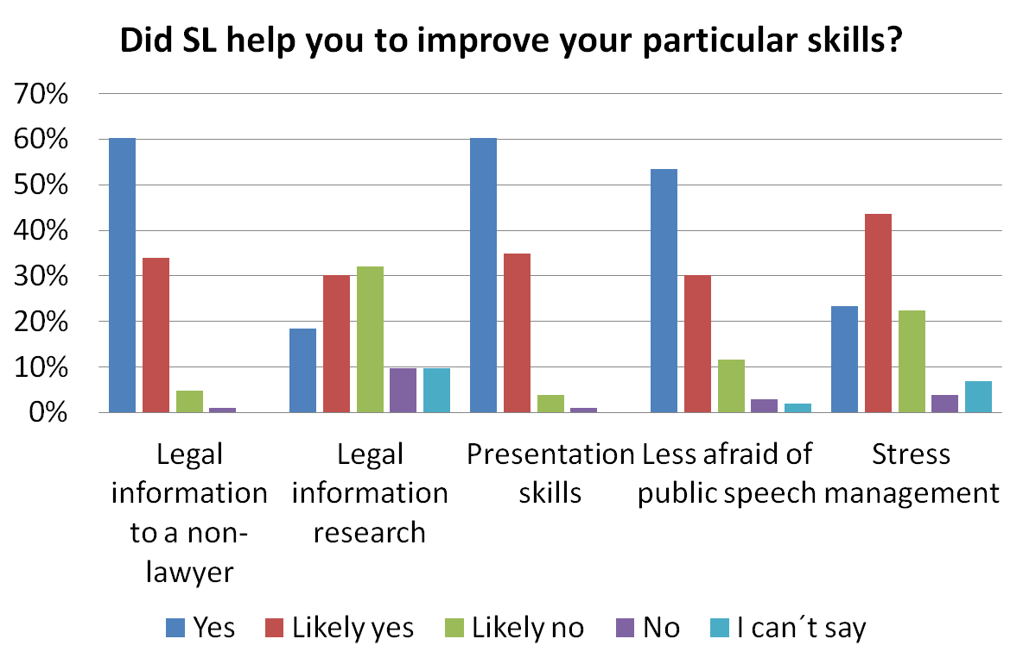
Graph n. 1: This graph reflects the results of the student point of view on the improvement of tested skills by passing the Street Law course.
As the graph n. 1 reflects, Street Law graduates highly appreciate that Street Law improved their ability to transfer legal information to a non-lawyer (60% yes, 34% likely yes). Another highly appreciated area were the presentation skills (60%, 35%), for development which there is usually not so much scope to develop in other, more traditional modules.
On the contrary, when the Street Law graduates were asked whether Street Law has helped them to improve their skills to research particular legal information (see in graph n. 1 under “Legal information research”), for which Street Law is usually highly appreciated, the numbers were much lower compared to other areas (18% yes, 30% likely yes). Although it is still almost 50% of the graduates who believe that Street Law has (or likely has) helped them to improve their research skill, the results are worse than in other areas. This is quite concerning and the reasons for this should be more closely examined. One of the possible explanations could be, that students are often covering the “secondary school” topics and they are usually using their notes and books from the subjects covered in the faculty of law to prepare them and accordingly to them this is not to be considered as finding particular new legal information. Another possible explanation might be based on the fact that within the Prague Street Law course there is currently no lesson in particular focusing on research skills, as much more space is given to the teaching skills. The results of the research should serve as an opportunity to reflect on this fact and add at least one research skill activity as a compulsory part of the course, so the students could prepare better lessons. Last but not least, this aspect of Street Law could be less appreciated also because of the fact that civil law legal research differs from common law and most of the prior papers this research draw on were from common law countries. Despite the results of the questionnaire I believe that Street Law has a potential to improve students’ research skills, which are important lawyering skills. However, we do not fully take an advantage of such a potential.
It can be summarised that the hypothesis that Street Law serves as an efficient tool to develop lawyering skills was confirmed. In general, Prague Street Law can be considered to be highly beneficial for the law student as for developing lawyering skills. However development of particular lawyering skills (transferring legal information to a non-lawyer or presentation skills) by Street Law is much more appreciated than others (e.g. legal information research) and attention should be paid to that when also designing the changes to the curriculum of the course to the future. As the law school is sometimes criticised for not focusing on development of legal skills enough, especially by its students, Street Law might serve as a good tool to balance that.
  - Teaching skills
As described above, Street Law can actually provide future lawyers with important skills, which every future lawyer can benefit from. Coming from the unique character of the course, next to the benefits for lawyers, students were separately asked about benefits from the point of teaching techniques they learn in the module, which could be seen as second important aspect of Street Law in Prague. However, it is important to acknowledge that those teaching skills are not solely for law teachers, but are more universal. As Street Law is known for its unique teaching method which is fully respected by Street Law in Prague, it was not surprising that the numbers were very positive. 95% stated that it helped them to learn how to teach in an interactive way (65% yes, 30% likely yes). Moreover, it helped them to learn how to plan their own lesson (74% yes, 21% likely yes) and how to communicate with secondary school students (67% yes, 29% likely yes). These results fully reflect the structure and content of the Street Law course as well as the unique goals and characteristics of Street Law in general concerned with the interactive and learners based approach.
However, it is important to realise that even though students stated it helped them, not all of the lessons are high quality even after the intense training. From our experience many students come to the classes expecting to prepare lectures for their school students and they are surprised by the range of activities they can use within their classes (problems solving, group work, simulations as well as mock trials). While some students adopt these techniques quite quickly and are able to come up with an amazing range of law based activities, it is sometimes very hard to explain to others that they could try to avoid the lecture style delivery to be used throughout or through most of their lessons.
  - Knowledge
Street Law is believed to be a powerful tool to deepen and extend the legal knowledge of law students. However, the number of respondents stating that Street law did not or did likely not help to develop their knowledge was surprisingly high (33%).

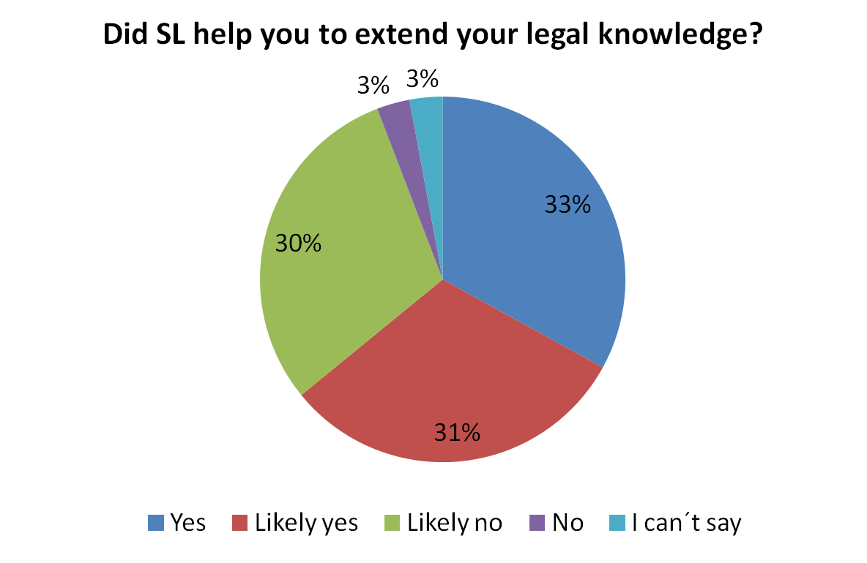
Graph n. 2: This graph reflects the results of the student point of view on extending their legal knowledge by Street Law.

There are two possible explanations for that result. Either Street Law does not have such a high potential to extend and deepen legal knowledge despite the theory. Or the emphasis on the legal knowledge is not sufficiently stressed during the classes, so students do not focus on deepening their knowledge, or do not realise that they did. Moreover, it could be connected with the results on finding out particular legal information discussed above.
Meanwhile, more than 60% of students still stated that Street Law did help to extend their legal knowledge (33% yes, 31% likely yes). Those students were asked for a concrete description on how did they deepen their legal knowledge and their answers can be summarised in two main categories, labelled as “class preparation” and “questions from their students”. Most of the respondents stated that during the class preparation they really needed to learn the topic properly and understand it to be able to transfer the legal knowledge to their school students/audience. Structuring the topic for non-lawyers and preparing concrete examples helped them to gain better knowledge and a more complex overview on the topic. The second most often stated reason were questions from their school students, which served as motivation for future learning either prior to the lessons, or following them. Students were more motivated to learn the topic properly to be able to answer the questions of their school students. Often they also needed to find out the right answer after the class as they were not able to answer it and promised to provide their school students with the right solution during the next lesson.
Another interesting and rather controversial topic raised by the questionnaire results was the fact, that present rules allow students to take the course from their first year. Especially while taking the course during the first year of their studies, they often face the situation when they need to conduct classes on topics they have not themselves studied at university yet. Even though students have a possibility to choose and are recommended to focus on topics they have already covered, it is not always possible. There can be arguments found for as well as against this setting.
Students usually teach in pairs, which should ensure the possibility to double check every lesson. The positive benefits of Street Law should be outlined to any student who is interested in Street Law. Younger students tend to have more time to join university offered opportunities, as later on they can get busy with extracurricular activities such as working part time in a law firm and there might be no space for Street Law at all. So is it better for a student to pass a Street Law course as a first year student or better not at all? Also, it was mostly students of the lower years who stated that Street Law helped them to extend their legal knowledge. However, even experienced lawyers often need to find out completely new information at times, so learning how to do that in early stage of studies might be useful.
However, there are a lot of arguments against Street Law being open for first year students. It might be argued that it is too hard for first year students to deliver a good lesson. Their research skills and legal knowledge might have not reached the lowest acceptable level to be vested with the responsibility of delivering a law lesson on their own. Considering the fact that it is not possible to supervise every single lesson, this situation could be dangerous for both, secondary school students, who might be delivered lower quality lesson, as well as Street Law students, who do not get a chance to realise whether the information they are delivering (and possibly learning themselves as well) is right or not.
As there is a high risk of harm, it seems better to postpone the possibility of signing up for the subject at least until passing the first year of the studies and such entrance barriers should be introduced in the future.
In conclusion, considering the legal knowledge development the data proved that Street Law has a potential to deepen and extend the legal knowledge of the law students and serve as an effective teaching method. However, as quite a large number of respondents did not value this aspect of Street Law, bigger focus and stress should be put on that during the classes in the future.
  - Values
“It is necessary to keep explaining to the public how law works and why it is important.”
“I realised how big is the distance between law and non-lawyers.”
Does Street Law have a potential to influence students perspective on law – the subject of their studies? Respondents were asked, whether Street Law influenced the way they perceive the law and it’s functioning. Despite the broad sense of the question, 44% of the respondents have been influenced by Street Law in that way (14% yes, 28% likely yes).
Answers of the 38 respondents on the question how did Street Law change their point of view on law, were of special interest. Students often reflected on the relationship between law and non-lawyers which they learnt to focus on during their teaching practice. As future lawyers they will very often either directly communicate with non-lawyers, or influence the non-lawyers by their professional conduct (e.g. writing a legal act), therefore it is of high importance to give the law students a chance to perceive the law from a non-lawyers point of view. The reflection was about how the law is not understandable, how important it is, how unfair it is not to have enough information or what the responsibility of lawyers means. It reflects the important social justice aspect of law, for which there is not always enough space in the “black-letter” lessons.
Another group of answers focused around approaching law as a system – Street Law helped the students to value the importance of the system, understand the basics of functioning of law and its meaning in much broader context then the regular subjects enabled them. Usually, students are studying particular subjects, but the overall overview of law as a system and its complexity can be easily gained during practice and Street Law offers this kind of experience.
In conclusion, the extra value of the Street Law course is that students can reflect on law as a system, its social function, professional responsibility of lawyers and the relationship between law and non-lawyers. It might be argued that this could be one of the most important benefits of Street Law as such.
  - Other benefits
Apart from predefined answers – hypothesis based on our experience and literature on Street Law – students were given a chance to further formulate what other benefits they feel they have gained from Street Law. 45% of respondents took the chance to answer and the most interesting and the most frequent answers are briefly summed up here.
Students appreciated the chance to meet with other students and create mini teams. It reflects the fact that the study environment at Charles University is very anonymous, as there are more than 600 students in each year and there are no study groups and unless you make a great effort you do not make study partners. Based on that it could be argued that Street Law has a high potential to develop team work skills, which are very important for lawyers as well, as they will often be part of a legal team (may it be in a law firm or a judicial senate). The fact that several students mentioned it on their own, although they were not explicitly asked about that in the questionnaire, might support that hypothesis.
Students also liked the chance to increase others legal literacy and have a contact with non-lawyers. Many of them stated that they liked the possibility to try out teaching.

- Street Law benefits and legal practice
After students replied to questions about the benefits they see in Street Law, we were interested in whether they consider that Street Law was actually beneficial for legal practice (contrary to the fact that at least at Charles University Street Law is often viewed mainly as didactical course by external viewers). First, they were asked whether they find Street Law beneficial for future legal practice. The results were surprisingly high (55% yes, 30% likely yes). That goes against a very often statement Street Law has to face – that it is good for future teaching, but has no real consequences for “the real lawyers”. However, only 20% of the respondents have actually used Street Law skills in practice, another 20% have likely used them, so there is quite a large difference between the potential and the actual influence of the legal practice by Street Law.

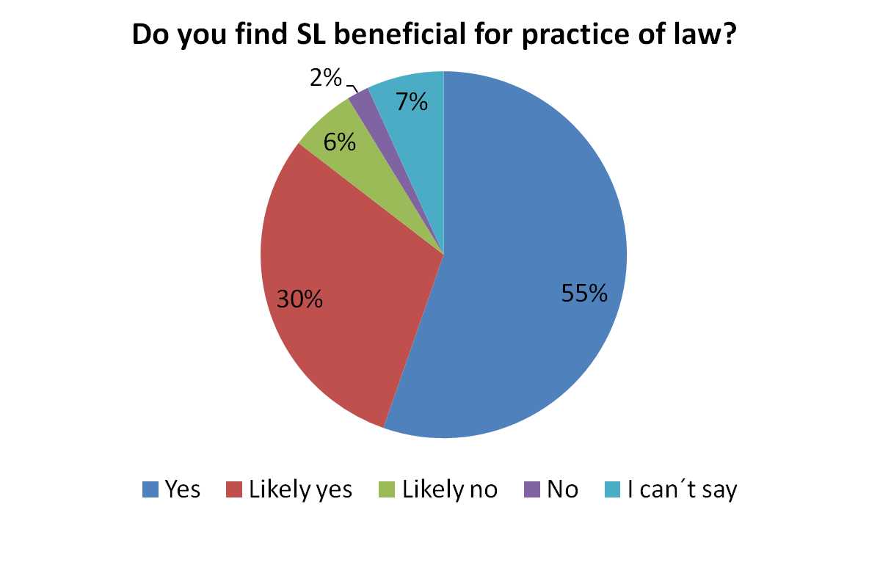
Graph n. 3.: Potential use of Street Law benefits in legal practice.

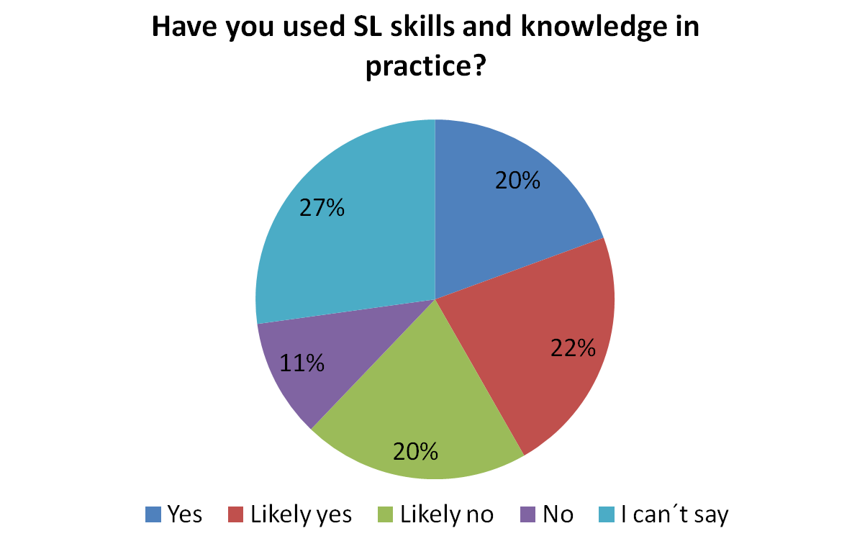
Graph n. 4.: Real use of Street Law benefits in legal practice.

And what were the situations respondents identified as examples of real use of Street Law skills in legal practice? The most frequent declared use of Street Law skills in practice was the communication of law to non-lawyers, especially clients in an attorney’s office, which is to be considered as highly important. Students come to the law school and are trained in using precise language and technical terms. However, as important as it is to use the precise terms to talk and think about the law, as important it is to have a skill to “translate” the law into an everyday language. If law students are going to pursue a legal career, most of them will at some point (and a lot of them very often) need to communicate the law to non-lawyers, may it be for the attorney to discuss the case with his client, or the judge to communicate with the parties, or the legislator to explain the impact of the novel legislation to non-lawyers. Street Law teaches its students to constantly think about and reflect on whether the information they present is going to be understood by the other party. I believe that even if this was the only thing students would take from Street Law, it would still make it suitable for every law student.
- Teaching in future – future in teaching?
A hidden benefit of Street Law may be its influence on future lawyers teaching law. As Michal Urban put it in 2011, when the Prague Street Law programme was only 2 years old, one of the ambitions of Street Law programme in Prague has been the involvement of law students and lawyers in teaching law. And this ambition has proved to be fulfilled. If we accept the statement that it is better to have lawyers to teach law and it is better to have lawyers trained in teaching law, then based on the research Street Law has a highly positive influence on teaching.
Very often Street Law serves as an option to try out teaching. The question is, whether after passing the course students continue with teaching or not and whether they feel it was the Street Law course that had an influence on that.
44% continued with teaching after passing Street Law, while 56% of students did not continue, although quite a few of them stated that they would like to continue and they are thinking about it and planning it in the future, or they regret that there was not such an option during their years. Those, who somehow did continue (44%), are analysed further. Street Law graduates can either continue with Street Law on faculty level (35%), or continue on their own (27%). 17% continued both, within and outside the faculty model.
Since the beginnings of Street Law in Prague many follow-up options have developed and 35% of respondents took advantage of that. Basically, you can either take another Street Law course (either an advanced Street Law course, which is much more demanding, or quite a light Consumer law oriented Street Law course). Another option open to Street Law graduates is to join a Street Law team as an extracurricular activity delivering different legal workshops to the public.
27% of respondents continued with teaching outside of the law school. Very often they stated that they continued teaching in secondary schools (either on regular basis or with occasional project lessons). Furthermore, some PhD students or participants of civic society project appeared within the respondents.
Secondary schools, law schools (where didactical training is not always an inherent part of PhD studies) and civic society projects are important and the more qualified lawyers-teachers there are, the better. Street Law then proved to be an effective strategy, how to provide more such trained persons into the system. Although it is not to be designed as a direct benefit exclusively for the students, it is definitely a benefit for the society to have more trained teachers-lawyers actively taking part in teaching law. 44% did somehow continue with teaching. 38% of respondents are still teaching in the present at least occasionally; in absolute numbers, that is 39 trained law teachers Prague Street Law has provided to the community, who are teaching at the moment at least occasionally. Moreover, 86% (33) of those stated that it was Street Law that influenced them.
- Summary
Answers from 103 Prague Street Law graduates helped us to reflect on the past 9 years of the basic Street Law course at Charles University in Prague. It helped to confirm that the Street Law course can be very beneficial for students. In general, from all the answers those answered with a negative point of view were by only one student, which is surprisingly little. The positive reflection of the graduates was confirmed given that 88% indicated they would sign up again, with an additional 9% likely signing up again.
The research proved that Street Law graduates feel that Street Law helps to develop key skills for lawyers, among which communication of legal information to a non-lawyer proved to be one of the most important, followed by presentation skills. The important realisation is that those benefits make it suitable for every regular law student, not only those who are interested in teaching in future. Therefore even though Street Law is often considered to be a secondary activity, it has proven to be suitable and useful for law students in general, as important lawyering skills are strengthened through it.
A positive externality to be stressed is that Street Law serves as a platform to produce trained law teachers, who then often continue in increasing legal literacy of non-lawyers even after passing the course (38% of Street Law graduates are still teaching at least occasionally).
However, some “not so satisfying results” are important for a reflection of the present Street Law course. For now, 3 main changes should be introduced in order to improve the impact of Street Law on its students and hopefully this might serve as an inspiration for those who might be facing similar problems. First of all, the course must include a legal research workshop. Second of all, larger stress needs to be put on extending legal knowledge by Street Law by both explaining this and checking on their progress. The third change should be based on introducing entrance barriers based on the study year.
However, in general the data was mostly positive and it proved Street Law to be beneficial for its students. I hope this research would also serve as a support for those, who are thinking about establishing a Street Law clinic at their law school, as it proves that it is a valuable teaching tool.
If we return to the question from the beginning of this article, whether Street Law can produce better lawyers, the answer based on this research is definitely a “YES”.

Hana Draslarová, PhD student at Charles University in Prague, Faculty of Law, focusing on legal education. She has herself passed the Street Law course in 2012 and now she has been participating at conducting a Street Law course for 3 years. E-mail: draslarova@prf.cuni.cz. This text was supported by the Charles University Research Development Schemes, programme Progress Q18. The author is very grateful for the support and valuable comments of her dear colleagues Michal Urban and Tomáš Friedel.
For example see: ARTHURS, S., COOPERMAN, M., GALLAGHER, J., GREALY, F., LUNNEY, J., MARRS, B. & ROE, R: From Zero to 60: Building Belief, Capacity and Community in Street Law Instructors in One Weekend. International Journal of Clinical Legal Education, 2017, 24 (2), 123-126. Available online: http://www.northumbriajournals.co.uk/index.php/ijcle/article/view/599/1017 or GRIMES, R., McQUOID-MASON, D., O´BRIEN, E. and J. ZIMMER: Street Law and Social Justice Education. In: FS Bloch (ed.), The global clinical movement: educating lawyers for social justice. 2011, Oxford University Press, 225-240.
When I refer to students, I mean the university students of the faculty of law, unless specified otherwise.
Street Law benefits for the society are stressed in literature very often. For example see: GRIMES, R., McQUOID-MASON, D., O´BRIEN, E. and J. ZIMMER: Street Law and Social Justice Education. In: FS Bloch (ed.), The global clinical movement: educating lawyers for social justice. 2011, Oxford University Press, 225-240.
Prague Street Law program including the basic Street Law course owes a lot to its founder dr. Michal Urban, who established the basic course and has been conducting it since then. He is also in charge of the follow-up Street Law activities.
Next to the Street Law course there are other Street Law activities in Prague, both as a part of curriculum and as extracurricular activities. However, this text strictly focuses on the basic Street Law course as such, which also served as a foundation for the follow-up courses and activities.
For example See: PINDER, K. A.: Street Law: Twenty-Five Years and counting. Journal of Law & Education, 1998, 27 (2), 211-233.; or MOHD SUHAIMI, A., MOHD ZULKIFLI, N. F.: Street Law Based CLE: A Student-Impact-Assessment. International Journal of Clinical Legal Education, 2012, 18, 218-226. Available online: http://www.northumbriajournals.co.uk/index.php/ijcle/article/view/7/7; or GRANDE MONTANA, P.: Lessons from the Carnegie and Best Practices reports: A Look at St. John´s University School of Law´s Street Law Program Model for Teaching Professional Skills. Thomas M Cooley J Pract Clin Law, 2009, 11 (1), 97-126.
Lawyers can teach law on many levels including PhD students involved in teaching seminars or being a full time teacher at high school. However, the most common are part time teachers – professional lawyers (e.g. judges or attorneys), who enjoy teaching at high schools or universities at part-time basis.
It is important to realise that the law degree in the Czech Republic is a 5 year undergraduate master programme. Students can undertake a Street Law elective course at any stage of their studies, although this varied during the years.
For closer examination including the goals of Prague Street Law programme see: URBAN, M.: How to Discover Students’ Talents and Turn Them into Teaching. International Journal of Clinical Legal Education, 2011, 16, 144-153. Available online: http://www.northumbriajournals.co.uk/index.php/ijcle/article/view/51/55 or KRUPOVÁ, T., ZIMA, M.: Street Law and Legal Clinics as Civic Projects: Situation in the Czech Republic. Oñati Socio-legal Series, 2017, 7 (8), 1647-1660. Available online: http://ssrn.com/abstract=3075162
I recognise that the response rate is not very high; however in absolute numbers we still gained data from 103 individuals, which could make the answers interesting for readers.
That is interesting as in the Czech educational system there are mostly women teaching.
ARBETMAN, L.: Street Law, Inc.: Context, History and Future. International Journal of Public Legal Education, 2018, 2 (1), 5. Available online: http://www.northumbriajournals.co.uk/index.php/ijple/article/view/705/1097
For a Street Lawyer it might be hard to imagine Street Law lessons to be lecture based only. However, it is not law that would make the interactive teaching inseparable from Street Law.
Examples of the answers of the respondents.
The impact in that direction is further assessed in paragraph 6.
Such “attacks” are not exclusive for the Czech Street Law programme, but other programmes often face similar problems. See: PINDER, K. A.: Street Law: Twenty-Five Years and counting. Journal of Law & Education, 1998, 27 (2), 225.
Students may of course learn that skill somewhere else as well, but Street Law is proven to be effective in that way.
URBAN, M.: How to Discover Students’ Talents and Turn Them into Teaching. International Journal of Clinical Legal Education, 2011, 16, 144-153. Available online: http://www.northumbriajournals.co.uk/index.php/ijcle/article/view/51/55
Students were asked about their motivations to sign up and the most frequent answers were “possibility to try out teaching” and “extraordinary elective module”.
Public legal education is recently slowly getting more popular in the Czech Republic. For example the Czech Bar Association started its project “Advocates to Schools”, where it is supporting its members to give legal lectures in the schools.
There are workshops run by Street Law course students for other schools, prisoners, elderly people, children homes to name but a few. For further details see: URBAN, M. Why there is a need for Street Law programmes? International Journal of Public Legal Education, 2017, 1 (1), 98-103. Available online: http://www.northumbriajournals.co.uk/index.php/ijple/article/view/643/1053 or URBAN, M., DRASLAROVÁ, H.: Street Law for Czech and Slovak Young Roma Musicians. International Journal of Clinical Legal Education, 2016, 23 (3), 148-171. Available online: http://www.northumbriajournals.co.uk/index.php/ijcle/article/view/534/924
The Prague Street Law programme is further running educational activities for full time high school teachers, where they can deepen their legal knowledge as well as train their teaching skills. Those courses aim primarily at those non-lawyers who are teaching law on regular bases.

