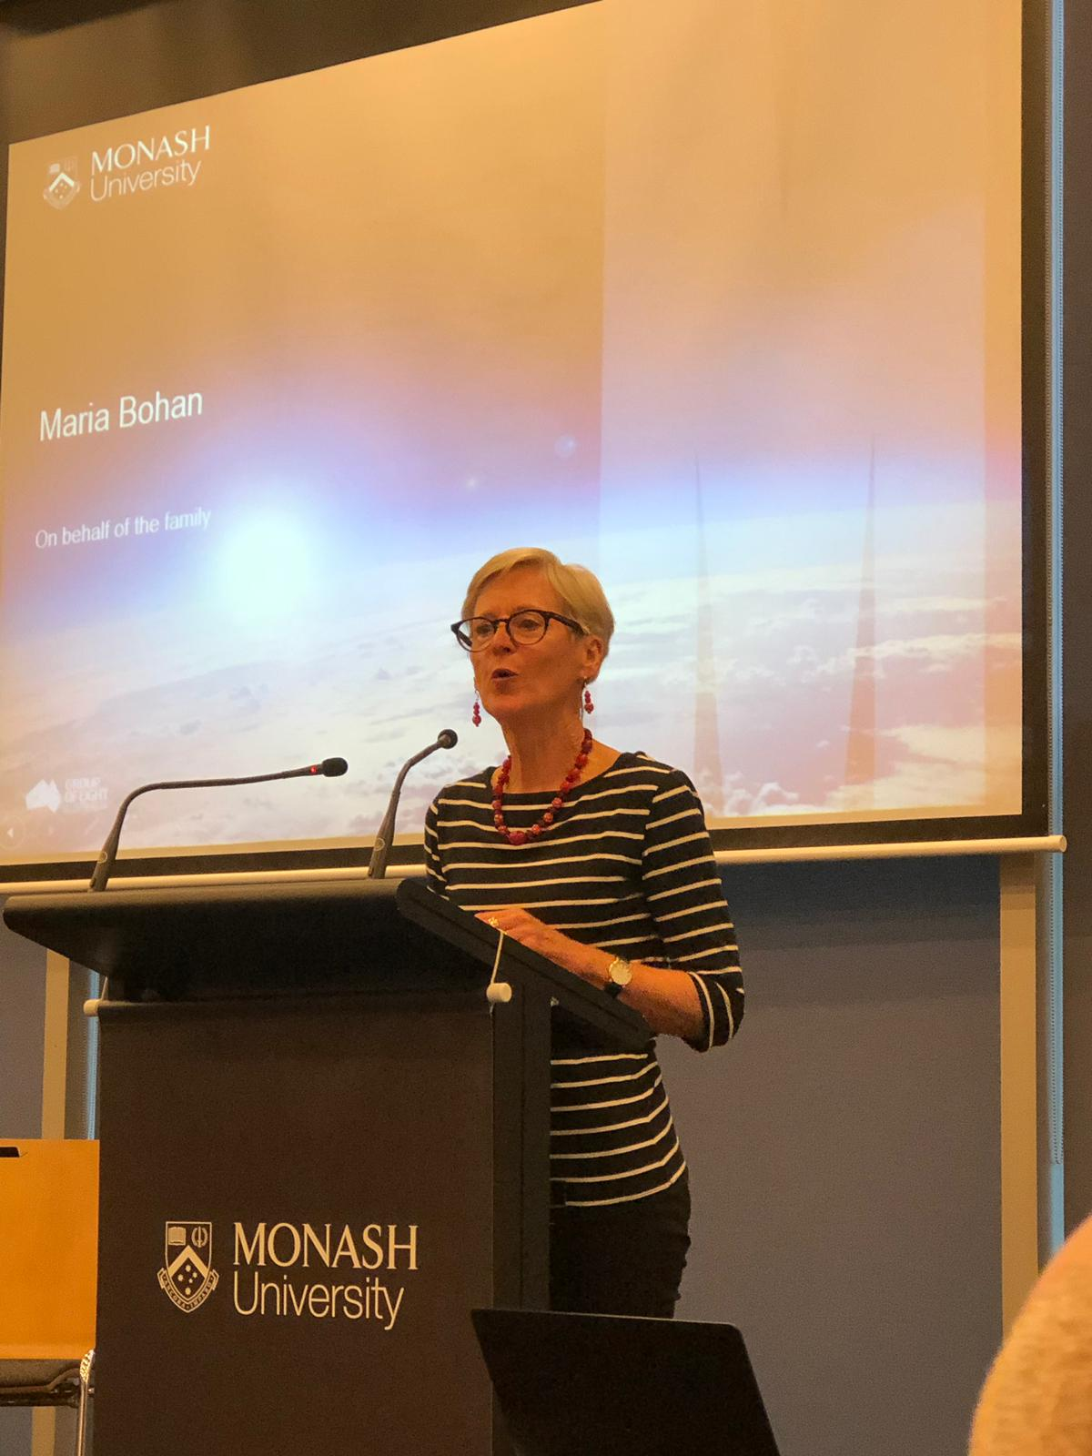***SOME THOUGHTS . . .***

***Maria, Family & Friends***

**Thank you all for being Adrian’s colleagues, collaborators and friends.**

**A few things you may not know . . . . about our Adrian, plus some family and friend thoughts.**

**Clinical practice on the home front . . . .**

One morning as I’m rushing out the door at 5.30am,

Adrian says “I’m working from home today - how about I do Spaghetti Bolognese for dinner?”

“Sounds great. How about you put some spinach in it? There’s lots in the vegie garden - just make sure you soak it and wash it several times - the snails like to hide in it.”

Many hours later, we sit down for dinner, sprinkle the parmesan, take our first mouthful . . .. crunch, crunch . . . . have we all broken a tooth at the same time?

The boys and I look at each other, pause, and then push our bowls to the centre of the table.

“Just what is in this Dad?”

The search begins. . . . . dozens of tiny snails.”

Come for dinner sometime!!!

You are most welcome.

**Ethics – On our weekends!**

Over the years when Geelong has been in the finals, Adrian heads off to Monash for the Staff Grand Final Football Morning Tea - or whatever it is you have.

Dressed to kill in borrowed Cats jacket, scarf, cap, badges.

We need to let you know that he knows nothing about footy.

He’s a total fraud!

We used to let him come with us.

He would sit in the stand reading the Age and then The Saturday Paper, every now and then, trying to tell us stories about corruption or similar.

A bit later, after noticing the ads around the ground, would come a lecture about alcohol and gambling advertising. Of course, we all totally agreed but “Would you just shut up for an hour or so? The game is on a knife’s edge, Geelong is behind by 2 points!”

A bit later after seeing a screen shot of the AFL CEO, we would hear another mini lecture about the corporation that is the AFL . . . and being corrupted by gaming companies! And yes, again we agree, for sure, but could we just watch the game please?

So now, we don’t let him see the fixture, we don’t tell him how much our memberships cost - we just head off.

He does however, pay for all the fun Cats clothing we buy for our grandchildren!

***And there’s a little PS:*** This year on Saturday mornings, during the AFLW, I would have ABC Radio on, and would often have to say . . . “Please be quiet . . .. it’s the Outer Sanctum Program.”

“What’s that?” he would ask!

**Maybe to help Adrian live with a feminist** . . . . . he’s in a **Men’s Group** and for today the blokes collectively sent this message:

Adrian founded our Men’s Group 30 years ago so we could all reflect and support each other on the broad range of experiences of being male in a changing world.

He is committed to taking action, driven by social justice and responsibility, including reducing the human environmental impact . . . . his house is almost independent from the grid!

It will be when he puts in a wind turbine!

He is disinterested in competitive physical pursuits **unless** facing the challenges of a hike. Indeed, he is seldom happier than when he’s in the bush, with or without his gastronomic delight – tinned Spam!

**Some messages to Adrian . . . .**

**Adrian’s Friend Peter . . . .**

When the definitive research is done on the history of the Man Hug, Adrian will rightly be credited as a pioneer.  Although more commonplace now, Man Hugs could be fairly confronting in those early days.  Adrian had the knack of delivering the right combination of affection and force. I even think that occasionally, when there were a few quiet cracks of the vertebrae, Adrian’s Man Hug would realign the spine and improve the energy flow through the chakras. Quite a gift!

One of many he will bring into this new season of life.

Every blessing mate and a big hug.

**Adrian’s Friend Ray** . . . . .

Adrian - it has been a privilege having you as a constant and wonderful friend for more than 40 years.

A friendship spanning interests in ethics, world affairs, family matters, and especially what is happening to our planet.

Your integrity is beyond doubt and your compassion for others, an outstanding virtue.

We look forward to seeing more of you now!

**Adrian’s Sister Caroline says . . . .**

Adrian you give so much of yourself to everyone with whom you come into contact.

You are a fantastic father and grandfather and a great brother to me – always listening and affirming of my abilities. I love you very much and am very, very proud of you.

**Adrian’s brother Richard . . . .**

Adrian - stay strong in your knowledge of truth.

**And lastly, a few messages from ours, and Jenny’s, boys . . .**

**Impressive young men . . . .**

**Hugh**

There’s lots I could say about **Dad** as a role model, a teacher, someone who cares a lot about those less fortunate in life.

Growing up, Dad’s sense of humour was right out of the “Dad’s Sense of Humour” handbook, in fact he could have published his own edition, alongside his law books – maybe actually making money from a book.

I always hoped I would bypass this generic trait but I realize this humour is part of me too.

I’m very proud of my **Dad**.

**Dan**

**Dad -** I mostly remember you looking at me sternly over the top of your glasses, saying in a deep voice “Daniel!”

I am very proud that you have led a life walking your talk for the good of our society and our planet.

**James**

**Dad** you always tell us to vote for the Greens but you were seen last Saturday handing out How to Vote cards for Labor?

I think you are a most ethical professor - unless you find out that Aldi is owned by Woolworths and then you will be at a loss with nowhere to shop because poker machines are owned by everyone!

**Dad** you remain for me - the gold standard for doing the right thing in the world!

**Angus**

**Dad** you taught me a lot, not the boring stuff, but rather the important things – appreciation of good science fiction, trees, the environment new science, feelings.

I am very proud of you!

**And from me . . . .**

I too am very, very proud of you.

Adrian . . . . my best friend

My partner, my lover

What a ride we are on!

It sure is never boring!

Here’s to lots more learning and fun.

How privileged to have you by my side.

Let us now listen to Adrian’s favourite song . . . .

And your job - Adrian - is to think about:

* **why we are all proud of you, and**
* **why we all** **love you**!