Proposed Reforms to Partial Defences and their Implications for Mentally Disordered Defendants
Andy Bickle1
Introduction
Partial defences are special defences only available in England & Wales to defendants charged with murder. They include provocation, diminished responsibility, infanticide and killing pursuant to a suicide pact. These are known as the ‘voluntary manslaughters’ where homicide with intent otherwise sufficient for murder (‘malice aforethought’) is reduced to manslaughter because of defined mitigating circumstances2. Provocation and diminished responsibility have proved most problematic and will be the focus of this article. The mitigating factors arise from abnormal mental states, and psychiatric evidence has been at the centre of disputes regarding these defences. In this journal, Kerrigan set out recent problems that have developed with provocation in case law3. The degree to which mental disorder can be considered when deciding the standard of behaviour required of the defendant who pleads ‘provocation’ has fluctuated markedly in recent years. Diminished responsibility, on the other hand, has aroused concern, inter alia, over its expansive use to cover a wide range of mental conditions,4 and the frequency with which expert psychiatrists comment on the ‘ultimate issue’ of whether all limbs of the test are met5. Both problems might be said to arise from vague terms in the statutory definition that are incompatible with contemporary psychiatric practice.
Following the controversial case of R v Smith (Morgan James)6, which permitted mental disorder a much greater effect on provocation, the United Kingdom Government asked the Law Commission7 (‘the Commission’) to consider and report on the law and practice of the partial defences provided for by the Homicide Act 1957. This progressed to investigation into wider homicide law and a process of consultation and review which has now passed to the Ministry of Justice. This paper will outline briefly the review process before considering in greater detail the current proposals for new definitions of provocation and diminished responsibility. The Commission would like these to exist within a radically re-structured law of homicide. The implications for mentally disordered defendants and therefore expert psychiatric opinion will be considered.
Partial Defences to Murder: Consultation Paper (2003)8 & Final Report (2004)9
The Law Commission had long considered the law of murder in need of review10. However, a wholesale revision was outside its initial terms of reference and so it first considered partial defences in relative isolation. The Commission recommended new principles to govern a reformed provocation defence which omitted reference to the problematic ‘reasonable man’ whose mental characteristics had been causing the courts so many problems11. It also considered a new defence of ‘excessive use of force in self-defence’, principally to benefit female domestic violence victims, but ultimately preferred instead to reformulate provocation in such a way as to afford better justice to this type of defendant. In contrast, in this first review the Commission recommended no change to the statute definition of diminished responsibility for as long as the law of murder remained unchanged and conviction resulted in a mandatory sentence. However, it suggested a reformulation for further consultation which replaced the problematic concept of ‘mental responsibility’ (which many experts felt was outwith the expertise of psychiatrists) with a substantial impairment of capacity to understand, judge and exert self-control.
Notably, the Commission’s overarching recommendation to the Government was to review the law of homicide as a whole, including the mandatory sentence for murder. It argued the laws of voluntary manslaughter needed to be reviewed alongside those of murder to ensure coherence between the two12.
A New Homicide Act for England and Wales? (2005)13 & Murder, Manslaughter and Infanticide (2006)14
Consultation
The Law Commission was granted its first wish and invited to review various elements of murder, including the partial defences. The consultation did not examine euthanasia, suicide or abortion, except as they formed part of murder as the Commission believe the fundamental issues involved require separate debate. It also considered creating a new partial defence of duress, which is uniquely unavailable to the charge of murder in England and Wales15. The Commission was asked to involve key stakeholders such as the public, criminal justice practitioners, academics, those who work with victims’ families, parliamentarians and faith groups and accordingly a significant contribution was made by the Royal College of Psychiatrists as well as individual psychiatrists.
The Law Commission’s wishes were not, however, all granted. Pointedly, its terms of reference did not include the mandatory sentence. The Commission neatly sidestep this restriction by proposing a grading of homicide and reserving the mandatory sentence for ‘first degree murder’, thereby creating space for other (second degree) murderers to be subject to flexible sentencing. This legal dexterity has been described as “a risky subterfuge”16.
Structure of Homicide Law
The Law Commission reported in November 2006. Underpinning all of its other recommendations is a fundamental change to the structure of homicide law. It found widespread support (including from the Royal College of Psychiatrists) for its proposal to introduce a ‘ladder’ of offences creating degrees of murder and so change the distinction between murder and manslaughter that is almost certainly over 500 years old17.
The existing two-tier structure of homicide law is depicted below:
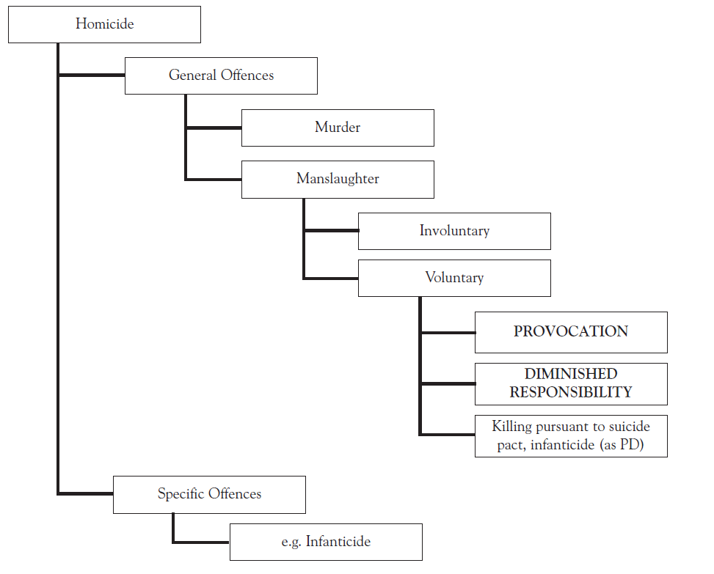
Fig. 1 Current Structure of Homicide
Within this structure there are two tiers of general offences (murder and manslaughter) in addition to specific offences including one based on psychiatric factors (infanticide).
The Commission finds the two-tier structure struggling to accommodate “changing and deepening understanding of the nature and degree of criminal fault and the emergence of new partial defences” and feels a more finely graded structure would be better equipped to handle these stresses and strains18. It emphasises the 1957 Act represented little more than tinkering with the existing law that elbowed a new defence of diminished responsibility into the existing structure.
The Commission prefers the three-tier structure of homicide it advocated from the beginning of the consultation exercise:
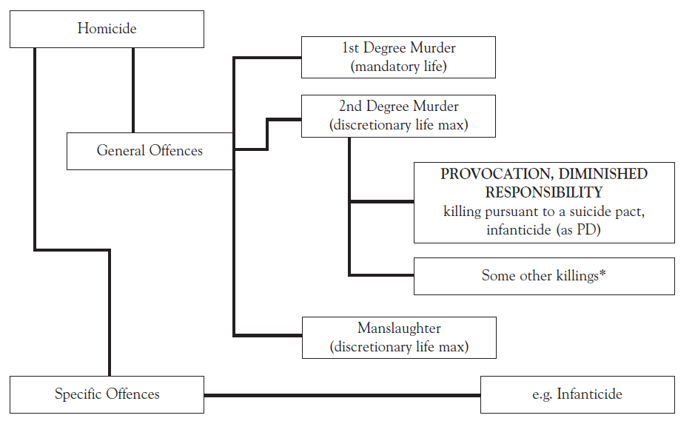
* Killing where offender intended to cause serious injury and killing where offender intended to cause
some injury or a fear or risk of injury, and was aware of a serious risk of causing death.
Fig. 2 Structure of Homicide Proposed by Law Commission
Under the new proposals, provocation or diminished responsibility would only reduce first degree murder to second degree murder. Partial defences would not be available to second degree murder or be able to reduce first degree murder all the way to manslaughter. The traditional justification for partial defences has been twofold. Firstly, they have allowed some sentencing flexibility. Secondly, they prevent less culpable offenders from being ‘labelled’ as murderers. In advocating this new three-tier structure, the Law Commission has made it quite clear that it views the primary and only essential reason for having partial defences is to circumvent the mandatory sentence19. The debate around ‘fair labelling’ is given only brief consideration and described as, “of secondary importance compared to the sentence mitigation principle”20. The Commission state that when an offender kills with the fault element for first degree murder but successfully pleads a partial defence, he or she still ought to be convicted of an offence of ‘murder’. This is a major departure from the current position, of course, and has been criticised by legal academics21. Ashworth finds difficulty in the attempt to group five different types of offence together in the category of second degree murder. This would include the three previous types of voluntary manslaughter and some cases which would currently meet a murder charge. Ashworth is willing to accept that current law is too generous to some reckless killings (involuntary manslaughters), but argues that if the culpability in such cases is so high, perhaps provocation and diminished responsibility cases should not receive the same label. This becomes an argument for an even more finely graded homicide law with perhaps four tiers, including a separate one for successful partial defences, which could be given a label such as ‘culpable homicide’ – a term borrowed from Scots law22.
The Commission justify witholding partial defences from second degree murder, believing they are not necessary for offences where the sentence will not be fixed by law. The Commission also cites concerns of the Royal College of Psychiatrists regarding the distorting effect of partial defences on expert evidence. The Royal College argued that psychiatric evidence of diminished responsibility is inevitably distorted as it must be made relevant to the verdict rather than the sentence23. The Commission believe making partial defences available to second degree murder would increase the number of cases in which psychiatric evidence would be distorted by making it material to the verdict. It might also employ a supplementary argument that expert opinion would be less distorted when the effect on the offence label is only to reclassify to a different grade of murder rather than to remove the label of murder altogether, meaning it has less impact on the verdict.
Another view advanced was that diminished responsibility should have a greater excusatory effect than provocation. In the consultation exercise conducted by the Commission, Mackay, who has completed much research on partial defences for the Commission, expressed his preference for diminished responsibility to reduce first degree murder to manslaughter even if provocation only reduced first degree murder to second degree murder or indeed was abolished24. The Commission recognise there may be advantages in this more nuanced approach, but conclude the benefits are outweighed by the drawbacks. Principally, it seems concerned by pragmatic issues. It cannot countenance a situation in which a jury agreed the defendant was not guilty of first degree murder, but nevertheless there needed to be a retrial because it was split between deciding if this should result in second degree murder or manslaughter. This further demonstrates the breadth of the proposed new offence of second degree murder incorporating offences of differing intent and, dare one say, culpability. It might seem counter-intuitive, but it appears that in the proposed new three-tier system, partial defences would find themselves alongside a more heterogenous group of offences than under the overall less differentiated two-tier system.
New Provocation
The Commission’s preferred definition of provocation remains unchanged from that advanced in Partial Defences to Murder: Final Report, save references to duress are removed. The definition is considerably longer than that it is intended to replace, consisting of sections (1) – (5). Section (1):
“(1) Unlawful homicide that would otherwise be first degree murder should instead be second degree murder if:
- the defendant acted in response to:
- gross provocation (meaning words or conduct or a combination of words and conduct) which caused the defendant to have a justifiable sense of being seriously wronged; or
- fear of serious violence towards the defendant or another; or
- a combination of both (i) and (ii); and
- a person of the defendant’s age and of ordinary temperament, i.e., ordinary tolerance and self-restraint, in the circumstances of the defendant might have reacted in the same or in a similar way.”25
Subsection (1)(a)(i) may not prove too controversial as it largely reflects the existing state of the law. However, the additional requirement that the provocation be ‘gross’ suggest that graver words or conduct may be expected. Subsection (1)(a)(ii), on the other hand, introduces ‘fear of serious violence’ as an entirely new basis for provocation. This new defence is intended to meet criticisms that the current law ‘goes wrong twice’ for women by making no provision for fear of serious violence to reduce murder to manslaughter and by permitting reduction in cases where the provoked murder may have been little more than a reflection of the continuing cultural acceptability of men’s use of violence in anger26. It has been argued previously that provocation discriminates against women27. This group has been regarded less likely to kill following a sudden loss of self-control in response to immediately proximal provocation, but more likely to have done so in fear of continued domestic violence. The Commission accepts that the current law discriminates by elevating anger to the only (partially) excused emotion and rebalances the equation by allowing in fear under (1)(a)(ii) & (iii). To right the second perceived wrong, the Commission has restricted, in its view unambiguously, the scope of provocation in (1)(a)(i)28. It should be noted that the removal of the requirement for a sudden loss of self-control to be replaced with a more relaxed approach of not acting in considered desire for revenge also opens up the possibility of other emotions than anger being permissible. Furthermore, the removal of sudden loss of control means that, depending on the circumstances, other acts, such as overreaction in self-defence, could satisfy the gross provocation requirement and result from a justifiable sense of being wronged without the defendant having experienced anger.
Moving on, subsection (b) begins to set out the standard of conduct expected of the defendant, and this should be read in conjunction with that which immediately follows:
“ (2) In deciding whether a person of the defendant’s age and of ordinary temperament, i.e. ordinary tolerance and self-restraint, in the circumstances of the defendant, might have reacted in the same or in a similar way, the court should take into account the defendant’s age and all the circumstances of the defendant other than matters whose only relevance to the defendant’s conduct is that they bear simply on his or her general capacity for self-control.”29
The difficult figure of the ‘reasonable man’ is omitted altogether but there remains an objective standard in the form of a person of the defendant’s age and of ordinary temperament. However, there exists the potential for many attributes to be given to this person. The provision for all the circumstances of the defendant to be taken into account other than matters whose only relevance is to self-control, is arguably narrower than the current provision in some respects, but wider in others. With regards to the application of mental state factors to the defence, it means that mental disorder could not be adduced if it is only relevant to the defendant’s self control. This would bar the defence in cases with similar material facts to those of the difficult case of Smith (Morgan James)30 in which alcoholism was successfully put forward as a factor to be taken into account when considering the required level of self-control31. Further, it would appear that a brain-damaged defendant (similar to the defendant in Luc Thiet Thuan v The Queen32 who was unsuccessful in pleading provocation) whose only relevant impairment was in self-control, such as might arise from damage to the frontal lobes of the brain, would not be able to put forward this defence. This may seem harsh upon a defendant who has an impairment arising from a head injury and prima facie it is difficult to see why someone with this sort of post-traumatic disorder should be less deserving than someone with a psychological injury such as post-traumatic stress disorder which predisposed them to a fear of serious violence, but it ought to be the case under the new proposals that by stating a specific (in)capacity to control him or herself in the new diminished responsibility definition (see below) any injustices could be avoided. To this extent the proposals seek to move the effect of mental disorder into the partial defence of diminished responsibility.
So how would mental disorder apply to the proposed partial defence of provocation? Firstly, mental disorder would continue to inform the court’s decision as to whether the defendant was sufficiently provoked to have behaved in the way they did. The Commission gives the example that low intelligence could be taken into account as part of the circumstances if it meant the defendant misinterpreted a provocative act, thinking it to be graver than a person of higher intelligence might have done33. More straightforwardly, mental disorder would apply where it formed the subject of provocative words such as name-calling.
Secondly, in allowing all circumstances of the defendant to be taken into account providing they do not only bear on self-control, the proposed definition opens new areas where mental disorder might apply.
This can be observed in relation to the new provision for fear of serious violence at (1)(a)(ii). Courts would presumably be asked to decide whether the defendant was indeed in fear of serious violence, paralleling the necessity for them to decide whether defendants relying on (1)(a)(i) were indeed grossly provoked. In other words, juries would likely be asked to decide on the gravity of the fear claimed by the defendant. One can imagine how certain mental disorders would be highly relevant to this requirement. It must be the case that identical acts will induce fear differently depending on the perception of the defendant which may be strongly influenced by mental disorder. For example, a defendant with post-traumatic stress disorder (well conceivable in the oft-quoted context of domestic violence) might be more fearful about the prospect of further enactment of that trauma than another person who did not suffer from intrusive mental re-experiencing of violence. Another example in relation to fear of serious violence might be the psychotic patient whose abnormal paranoid ideation predisposes him to interpreting acts of the victim as threatening. Reading (1)(a)(ii), (1)(b) and (2) together, one might put forward that the defendant’s reaction arose from fear to which he was predisposed because of a false belief that the victim wished him harm, developed secondary to auditory hallucinations telling him the same. Furthermore, it can be seen by this second example that mental disorder factors could be applied to other parts of the defence insomuch as such paranoid ideation could also be expected to impact upon the justifiable sense of being wronged in (1)(a)(i). This second example also demonstrates how it appears there would be considerable overlap between provocation and diminished responsibility.
Next, the third section outlines conditions which bar the defence:
“ (3) The partial defence should not apply where:
- the provocation was incited by the defendant for the purpose of providing an excuse to use violence; or
- the defendant acted in considered desire for revenge.”34
Subsection (3)(a) clearly excludes cases in which the defendant has induced provocation by the victim to provide excuse for the subsequent act. This is intended to resolve a moderate degree of confusion that has arisen. At common law, ‘self-induced’ provocation was not regarded as sufficient. However, the Homicide Act 1957 required the defence to be put to the jury whenever there was evidence of a provoked loss of self-control and may have removed the common law restriction35. The Commission believe that the common law position should be reaffirmed36.
Subsection (b) sounds uncontroversial, but is of particular relevance to the new basis of acting in fear of serious violence. In fact, acting under considered desire for revenge alone is what is being barred here. The Commission prefer that some wish for revenge co-existing with a fear of serious violence would not bar this defence.
Section 4 provides further clarification on the matter of revenge:
“ (4) A person should not be treated as having acted in considered desire for revenge if he or she acted in fear of serious violence, merely because he or she was also angry towards the deceased for the conduct which engendered that fear.”37
This section qualifies the bar set out in (3)(b), allowing some anger to coexist with fear of serious violence without it being construed as revenge, consistent with the general approach of these proposals which acknowledge the defendant’s behaviour may be influenced by several emotions and mental state factors simulaneously38.
Section 5 addresses a notable omission in the existing law:
“(5) A judge should not be required to leave the defence to the jury unless there is evidence on which a reasonable jury, properly directed, could conclude that it might apply.”39
Unlike other defences, currently a judge must put the defence of provocation to the jury if there is some evidence of there being provocative acts or words, even if he or she feels the defence unmeritorious. The Commission feels this must raise the probability of defences succeeding (indicating, perhaps, limited faith in the ability of juries to weed out poor claims). It asserts this was probably not the intention of Parliament in passing the 1957 Act, but rather an oversight. Other passages of the report hint at this being more than simply a ‘tidying up exercise’, as the proposed ability of the judge to withhold defences from the jury is relied upon to prevent miscarriages of justice such as successful claims based on revenge-driven acts.
New Diminished Responsibility
The Law Commission feels that medical science has moved on considerably since diminished responsibility was placed on the statute books half a century ago and consequently the definition is badly out of date40. It notes that the existing definition does not make clear that the ‘abnormality of mind’ must reduce culpability or explain how it does so. Furthermore, the Commission highlight that the use of the term ‘abnormality of mind’ does not accord well with psychiatric practice41. Its primary recommendation is to “modernise diminished responsibility so it is both clearer and better able to accommodate developments in expert diagnostic practice”42. This appears to place expert witnesses’ concerns at the heart of their proposals. Critics have expressed concern that psychiatrists frequently comment on what has been called ‘the ultimate issue’, in other words that they comment on all factors satisfying the defence including those which arguably should be left to the jury43. Importantly, the new definition omits the concept of ‘mental responsibility’ which many have perceived to be a moral judgement. The new defence would be based on a series of capacity tests that consider specific mental abilities:
“(a) a person who would otherwise be guilty of first degree murder is guilty of second degree murder if, at the time he or she played his or her part in the killing, his or her capacity to:(i) understand the nature of his or her conduct; or
(ii) form a rational judgement; or
- control him or herself,
was substantially impaired by an abnormality of mental functioning arising from a recognised medical condition, developmental immaturity in a defendant under the age of eighteen, or a combination of both;”44
Drawing in this way upon capacity to form the basis of legislation appears congruent with recent trends in clinical practice and other legislation culminating, of course, in the Mental Capacity Act 2005. Indeed the first two capacities appear familiar, approximating as they both do to elements of the statutory test set out in the MCA 2005,45 as well as the preceding case law on decision-making capacity. This test may, in fact, have the effect of formalising the approach to ‘mental responsibility’ frequently taken by experts as evidence suggests psychiatrists tackle the current requirement for (a substantial impairment of) ‘mental responsibility’ by disaggregating it into putative component mental abilities46.
One objection to the current test of a ‘substantial impairment of mental responsibility’ is that the question of the defendant’s mental responsibility sounds like one of moral and/or legal philosophy and something in which psychiatric experts do not feel they have special expertise47. However, even if it were accepted that mental responsibility could be formulated in terms of cognition or mental abilities (and it should be remembered that notwithstanding their misgivings, most experts do in fact make some comment on mental responsibility), there is the question of whether any impairment was substantial. Even if an opinion on mental responsibility has been offered, arguably it only becomes the ‘ultimate issue’ if the degree of impairment has also been addressed. Perhaps it is not, therefore, such a problem, but the new formulation would make the respective roles of expert and jury much clearer. It seems that framing impairment(s) in terms of capacities places the issue firmly in the domain of psychiatry. Helpfully, the text of the report explains that it is then for the jury to say whether the relevant capacities are ‘substantially impaired’48. The expert’s role is set out clearly to offer an opinion on:
“(1) whether the D [the defendant] was suffering from an abnormality of mental functioning stemming from a recognised medical condition; and
(2) whether and in what way the abnormality had an impact on D’s capacities, as these are explained in the new provisions.”49
It will be noted that only one of the three capacities need be substantially impaired for the defence to succeed. The first capacity bears some similarity to elements of the test for insanity in England and Wales. To “understand the nature of his or her conduct” sounds rather like, “to know the nature and quality of the act he was doing” as famously set out in M’Naghten’s Case50. Would the interpretation of ‘nature of conduct’ extend to the moral quality of the act, or in other words, “that he did not know he was doing what was wrong”? If not, it could be suggested that this would create a paradox because in this regard the full excusatory effect of insanity would be more available than the partial excusatory defence of diminished responsibility.
The second limb concerns the defendant’s capacity “to form a rational judgment” and seems to reflect the conventional requirement in decision-making capacity to weigh up information. Of course, there is generally no requirement in current law for the decision arrived at to be sensible and presumably neither would there be here (only the capacity for a rational decision to be made).
Moving on to consider the final paragraph of section (a), it can be seen that ‘abnormality of mental function’ has replaced the antiquated, although perhaps not excessively problematic, ‘abnormality of mind’. The Commission highlights that ‘abnormality of mind’ was a legal and not psychiatric term and feels the new definition has been drafted with the needs and practices of medical experts in mind. More important, perhaps, is the change to the aetiology of the mental impairment. In existing law there is a requirement for the abnormality of mind to arise from, “a condition of arrested or retarded development of mind or any inherent causes or induced by disease or injury”51. This would be replaced with a requirement in adults for the impairment to arise from ‘a recognised medical condition’. Curiously, the Commission regarded the existing terms too restrictive. Other authorities believe the terms have never been satisfactorily defined52. It does seem that a very wide range of mental disorder has been formulated successfully as one of the three underlying conditions, and there is a strong argument that less serious mental conditions have been allowed in order to ensure more a lenient sentence or disposal, for example in cases of so-called ‘mercy killings’ perpetrated by relatives of terminally ill victims53. It is hoped that the new definition would bring clarity to proceedings and allow psychiatrists to limit themselves to recognised diagnoses. It was certainly the belief of the Royal College of Psychiatrists that the proposed restriction would ensure that any such defence was grounded in valid medical diagnosis and would encourage experts to use recognised psychiatric classification systems54. This has the potential of being more restrictive towards the perpetrators of mercy killings, although given the likelihood of depressive or trauma-related symptoms in this group it will surely be possible for the courts to show leniency if it is their will until the type of wider investigation into euthanasia recommended by the Commission has taken place. Although, such a development would open up psychiatric classification systems, it would probably not change dramatically the disorders deemed acceptable as the current definition is broad, but it would seem to be more accommodating to personality disorders by allowing them to stand as their familiar clinical classifications rather than having to frame them as arrested development, disease or injury or as an inherent cause.
The other two changes to the basis of the abnormality in mental functioning/mind relate to defendants under the age of eighteen. Firstly, the new formulation allows the substantial impairment of mental functioning to arise from developmental immaturity. This addresses a lacunae in the current law which means that normal developmental immaturity cannot be allowed to form the basis of the defence55. This seems important in a jurisdiction where criminal responsibility may be assumed from the age of ten. Secondly, the final provision which allows a defendant under eighteen to be impaired by a combination of a recognised medical condition and developmental immaturity obviates the need to separate artificially these factors in a defendant of that age.
Next, the second section of the new definition contains a requirement for a link between the abnormality of mental functioning and the fatal act or omission:
“(b) the abnormality, the developmental immaturity, or the combination of both provides an explanation for the defendant’s conduct in carrying out or taking part in the killing.”56
The current law does not make explicit that there must be a link between the abnormality of mind and the offending behaviour. The new proposal requires an explanation based on the abnormality before the defence can succeed. The Royal College of Psychiatrists cautioned against a situation where experts might be called upon to ‘demonstrate’ causation on a scientific basis rather than indicating the likely impact of the abnormality57. The Commission feel its terms ensured an appropriate connection between the abnormality of mental function or developmental immaturity and the killing. The phrasing of the requirement being for an explanation rather than anything stricter (such as the explanation) suggests the test does not require the connection to be demonstrated as an absolute truth at the expense of other explanations, which no doubt would have caused the Royal College concern. This seems based in realism and to reflect the level of evidence involved, which by its nature must be speculative.
Nevertheless, section (b) does call for the link between the abnormality of mental functioning and the act or omission to be made clearer than under the current regime. The current term ‘mental responsibility’ is vague and open to conjecture about moral connotations as described above. It seems that read together, the specific capacities in subsections (a) (i) - (iii) and the explanation required in section (b) mean that overall there is a requirement for the essential problem or disability at the heart of the defence to be made much more explicit.
Other Potential Defences
Alongside provocation and diminished responsibility, the Commission considered several other potential defences as part of the review: duress, infanticide, mercy killing, killing pursuant to a suicide pact and insanity.
Duress
Duress is a general defence that is uniquely unavailable to murder. The Commission felt at all stages of the exercise that this was not right. Circumstances involving duress arise when the defendant becomes involved in the killing of an innocent person but only because he or she is personally threatened with death or with a life-threatening injury and the only way to avoid the threat is to participate in the killing58. Under current law, the defendant would be convicted of murder and given the mandatory life sentence. The Commission point out that sentencing guidelines do not even mention duress as a mitigating factor for murder.
Interestingly, the Commission had initially proposed to make duress another partial defence, which won the support of consultees. However, it reconsiders, thinking this could lead to undue complexity in other areas of homicide citing the difficulty in applying it to second degree murder, attempted murder and manslaughter. Instead, it has gone further and proposes it should be a full defence.
Infanticide
The offence of infanticide will be familiar to many expert witnesses and others. What may be less well understood is that infanticide can also be advanced as a partial defence after a charge of murder has been made. The Commission finds no problem with the current definition, or its position within the structure of homicide, but rather with the procedure for ensuring that evidence of a mother’s mental disturbance at the time of the killing is heard at trial59. It is concerned that in cases where the defendant denies killing their infant they are unlikely to submit to a psychiatric examination and so are likely to be convicted of murder as they are, for the same reason, unlikely to run with any other defence dependent on mental state. The Commission proposes a new post-trial procedure in these cases:
“[I]n circumstances where infanticide is not raised as an issue at trial and the defendant (biological mother of a child aged 12 months or less) is convicted by the jury of murder [first degree or second degree murder], the trial judge should have the power to order a medical examination of the defendant with a view to establishing whether or not there is evidence that at the time of the killing the requisite elements of a charge of infanticide were present. If such evidence is produced and the defendant wishes to appeal, the judge should be able to refer the application to the Court of Appeal and to postpone sentence pending determination of the application.”60
The procedure around murder is already unusual in that all defendants should have a psychiatric report. The difference with this suggestion is that the first instance judge would refer the case to the Court of Appeal so an opinion could be obtained.
‘Mercy Killing’
The Commission was tasked with considering euthanasia only inasmuch as it formed part of the law of murder and not more widely. It has decided any substantive recommendation on this subject should wait for a more detailed consultation on the issue. It recommends a separate exercise examining whether the law should recognise a separate offence of mercy killing or a partial defence of this type61.
Killing Pursuant to a Suicide Pact
This is already a partial defence to murder under the 1957 Act. The Commission’s starting position was that this provision should be repealed. However, in the light of its decision not to pursue a mercy killing defence without specific consultation, it recommends retaining killing pursuant to a suicide pact as a defence at this stage62.
Insanity
The complete defence of insanity fell within the terms of reference of the review, but the Commission has decided not to address it, indicating it was not an area of law that seemed to give rise to real difficulty or anomaly63. It makes no firm conclusions about how insanity would operate alongside their proposed new provocation and diminished defences. The Commission hypothesises the new defences could be interpreted more or less restrictively than the current law, thus making insanity more or less likely to be advanced instead. Finally, it does not think its recommendations removes the theoretical distinction between insanity as an ‘all-or-nothing’ defence and diminished responsibility as a partial defence representing a point on a scale of mental responsibility.
What Next? The Government’s Response
The Commission has not published draft legislation with its report as it usually does with less controversial legislation. Instead, it recognises that further consultation will be needed before this can be taken forward. The Ministry of Justice finally responded in December 2007 with a brief written ministerial statement which outlined the Government’s plans. It has decided to proceed on a ‘step by step basis’ and look first at:
“(1) reformed partial defences to murder of diminished responsibility and provocation (including the use of excessive force in self-defence);
(2) reformed offences of complicity in relation to homicide; and
(3) improved procedures for dealing with infanticide.”64
The statement by the junior minister goes on to express the Government belief that, “it is right to deal with these crucial elements of the existing law before going on to consider the wider structural proposals from the Law Commission”65. Finally, the minister promises to publish draft clauses for consultation in Summer 2008 prior to introducing any necessary legislation.
Prima facie, the Government’s approach does not seem entirely consistent with that of the Law Commission. After all, the wider review of the homicide law followed the Commission’s assertion that partial defences could not be examined in isolation, but needed to be considered alongside their position and effect in homicide law as a whole. There must be a suspicion that the Government may revise the definitions of provocation and diminished responsibility but take reform no further. At the very least they have decided upon a process which would allow this to happen and which weakens the argument that reform of the definitions of partial defences and the structure of homicide law are inseparable. In short, the Commission’s ‘risky subterfuge’ regarding mandatory sentencing will not have paid off unless the Government eventually takes this review to a second step and is willing to countenance a discretionary sentence for some types of murder.
On balance, this article finds the definitions advanced by the Commission are somewhat broader than those currently in force. Overall, viewing the whole package of proposals, any increased availability of these defences appears to be balanced by a reduction in the excusatory effect of a successful plea to the (albeit important) one of allowing flexible sentencing. If the Government accepts the Commission’s definitions, it may be a desire to revisit the overall balance of reform that drives the review process forward to a second step.
Conclusions
Precipitated by problems with partial defences to murder, the UK Government asked the Law Commission to review homicide law as a whole. Its resulting proposals would radically restructure homicide law and make substantial revisions to provocation and diminished responsibility. It would also introduce duress as a full defence to murder and make important changes to infanticide. The Commission recommends the Government hold the debate around euthanasia elsewhere and retains killing pursuant to a suicide pact until such a consultation has been completed.
The Commission’s proposals would change the definition of the partial defences and the effect of a successful plea. The scope of provocation would broaden and be available to those who acted in fear of serious violence. It is hoped this would prevent injustice to abused female defendants. The troublesome figure of ‘the reasonable man’ has been omitted altogether, and with it some of the relevance of mental disorder in homicide to provocation. The Commission has signalled a clear desire to move much of the effect of mental disorder on self-control ‘into’ diminished responsibility but has opened up new areas where mental disorder could be relevant to provocation as well as retaining its relevance to the gravity of provocation.
The new definition of diminished responsibility is capacity-based. Two of the capacities will be familiar to any doctor who has been concerned with assessing their patient’s decision-making ability, but the third (for self-control) is less familiar and arguably has the potential to make this defence more available to defendants with personality disorder and other disorders. The new definition appears to place assessment of the relevant impairment incontrovertibly in the domain of psychiatry. However, experts would not be expected to comment on the ultimate issue of whether the entire defence is satisfied. Crucially, the Commission expects juries to decide on the critical degree of impairment present. Other changes attempt to anchor the relevant abnormality in contemporary psychiatric diagnoses, recognise the role of normal developmental immaturity and make explicit the link between abnormality of mental functioning and the fatal act or omission.
The overall effect of the proposals might be seen as balanced in terms of the sympathy and excuse offered to mentally disordered offenders. The new provocation test would allow a greater number of defendants to plead this defence successfully, especially female defendants with the psychiatric sequelae of trauma. Most mental health concerns excluded from the self-control limb of provocation should be absorbed into diminished responsibility. The diminished responsibility test is more detailed than that it is intended to replace, but as only one of the newly-identified capacities need be substantially impaired, more defendants may ‘pass’ the test. The increased availability is contrasted by the reduced effect of a successful plea. The defences would only reduce first degree murder to second degree murder. The Commission argues that flexible sentencing is the only allowance this group of offenders absolutely require to meet justice. However, it cannot be entirely unimportant that these offenders will no longer be convicted of manslaughter but rather be labelled as ‘murderers’, albeit of a lesser degree.
The overall package of reform proposed is a most interesting one with several attractions, but will also present significant challenges to mentally disordered defendants, their legal representatives and those submitting psychiatric evidence. The momentum now lies with the Government which, with regard to partial defences, has decided to first review provocation and diminished responsibility definitions as well as procedural aspects of infanticide, before there is any possibility of advancing a further step to consider the Commission’s other proposals. Further consultation with interested parties is promised and it is clear that this process of review which started in 2003 is some way from being completed.

1 Specialist Registrar in Forensic Psychiatry, East Midlands Centre for Forensic Mental Health, Arnold Lodge, Leicester.
2 Ormerod D (2005) Smith & Hogan Criminal Law (11th Ed). Oxford University Press: Oxford: 471.
3 Kerrigan K (2006) Provocation: the fall (and rise) of objectivity. Journal of Mental Health Law May: 44.
4 Editorial ‘Partial Defences to Murder’ [2004] Criminal Law Review: 1
5 Mitchell B (1997b) Putting diminished responsibility law into practice: a forensic psychiatric perspective. Journal of Forensic Psychiatry. 8(3): 620.
6 R v Smith (Morgan James)7 [2001] 1 AC 146
7 The Law Commission is an independent statutory body created by the Law Commissions Act 1965 to keep the law under review and assist with reform. The Commission conducts research and consultations in order to make recommendations to Parliament. More than two thirds of the Commission’s recommendations for reform have been implemented (www.lawcom.gov.uk).
8 Law Commission (2003) Partial Defences to Murder: Consultation Paper. Law Com No. 173, TSO, London.
9 Law Commission (2004) Partial Defences to Murder: Final Report. Law Com No. 290, TSO, London.
10 Ibid, para 1.1.
11 Ibid, para 1.13.
12 Ibid, para 1.12.
13 Law Commission (2005) A New Homicide Act for England and Wales? An Overview. Law Com No. 177, TSO, London.
14 Law Commission (2006) Murder, Manslaughter and Infanticide. Law Com No. 304, TSO, London.
15 It is available to other charges in this jurisdiction.
16 Wilson W. (2006) The Structure of Criminal Homicide. Criminal Law Review: 471.
17 Law Commission (2006) Murder, Manslaughter and Infanticide. Law Com No. 304, TSO, London, para 1.32.
18 Op Cit.
19 See Wilson Op. Cit.
20 Law Commission (2006) Murder, Manslaughter and Infanticide. Law Com No. 304, TSO, London, para 2.147.
21 For example, see Ashworth in [2007] Crim Law Review.: 333.
22 Crichton J, Darjee R & Chiswick (2004) Diminished responsibility in Scotland: new case law. Journal of Forensic Psychiatry & Psychology. 15(3): 552-565.
23 Law Commission (2006) Murder, Manslaughter and Infanticide. Law Com No. 304, TSO, London, para 2.153.
24 Law Commission (2006) Murder, Manslaughter and Infanticide. Law Com No. 304, TSO, London, para 2.134.
25 Ibid, para 5.11
26 Ibid, para 5.63.
27 Horder J (2005) Reshaping the Subjective Element in the Provocation Defence. Oxford Journal of Legal Studies. 25(123).
28 Law Commission (2006) Murder, Manslaughter and Infanticide. Law Com No. 304, TSO, London, para 5.64.
29 Law Commission (2006) Murder, Manslaughter and Infanticide. Law Com No. 304, TSO, London, para 5.11.
30 R v Smith (Morgan James)32 [2001] 1 AC 146
31 A different view on alcoholism and self-control was later taken by the Privy Council in Attorney General for Jersey v Holley [2005] UKPC 23.
32 Luc Thiet Thuan v The Queen [1997] AC 131
33 Law Commission (2006) Murder, Manslaughter and Infanticide. Law Com No. 304, TSO, London,.para 5.43.
34 Ibid, para 5.11.
35 See, for example, R v Johnson [1989] Crim LR 738 in which provocation was not precluded by the fact that the provocative attack by the victim was a predictable result of the defendant’s conduct.
36 Law Commission (2006) Murder, Manslaughter and Infanticide. Law Com No. 304, TSO, London, para 5.79.
37 Ibid, para 5.11.
38 For example, see the proposals for diminished responsibility which allow a combination of a recognised medical condition and developmental immaturity. Notably this section coheres well with the first section of the provocation proposals where a combination of fear of serious violence and gross provocation (which may often, if not always, be expected to result in anger) may provide a basis.
39 Law Commission (2006) Murder, Manslaughter and Infanticide. Law Com No. 304, TSO, London, para ?..
40 Law Commission (2006) Murder, Manslaughter and Infanticide. Law Com No. 304, TSO, London, para 1.49.
41 Ibid, para 5.111.
42 Ibid, para 5.107.
43 Mitchell B (1997b) Putting diminished responsibility law into practice: a forensic psychiatric perspective. Journal of Forensic Psychiatry. 8(3): 620.
44 Law Commission (2006) Murder, Manslaughter and Infanticide. Law Com No. 304, TSO, London, para 5.112.
45 S. 3 MCA 2005.
46 Mitchell B (1997b) Putting diminished responsibility law into practice: a forensic psychiatric perspective. Journal of Forensic Psychiatry. 8(3): 620.
47 Op Cit.
48 Law Commission (2006) Murder, Manslaughter and Infanticide. Law Com No. 304, TSO, London, para 5.118.
49 Ibid, para 5.117.
50 M’Naghten’s Case 53 (1843) 10 CI & Fin 200
51 Homicide Act 1957, s2.
52 Ormerod D (2005) Smith & Hogan Criminal Law (11th Ed). Oxford University Press: Oxford: 469.
53 Mackay R. [1999] The Abnormality of Mind factor in Diminished Responsibilty. Criminal Law Review: 117.
54 Law Commission (2006) Murder, Manslaughter and Infanticide. Law Com No. 304, TSO, London, para 5.114.
55 S2 of the Homicide Act 1957 requires an abnormality of mind to cause the substantial impairment in mental responsibilities, which does not accomodate normal developmental immaturity.
56 Law Commission (2006) Murder, Manslaughter and Infanticide. Law Com No. 304, TSO, London, para 5.112.
57 Ibid, para 5.123.
58 Ibid, para 1.54.
59 Ibid, para 1.51.
60 Ibid, para 8.46.
61 Ibid, para 7.49.
62 Ibid, para 7.50.
63 Ibid, para 1.2-3. However in its report ‘Tenth Programme of Law Reform’ (11/6/08), the Law Commission list ‘Consideration of unfitness to plead and the insanity defence’ as one of their ‘new projects’.
64 http://www.justice.gov.uk/news/announcement_121207a.htm
65 Op Cit.

